Nature’s Call

Game design document

Authors

Danny Kruiswijk

Niels Hus

Tiemen Savonije

Jacky Schoen

Jasmijn Helweg

Contents

Game description 3

Target Market 3

Art and Video 4

Assets Pipeline 4

Production Schedule 5

Planning 5

Technical Specs 6

Code Versioning 6

Code Objects 6

# Game description

Defend the forest where many animals live and thrive the lumberjacks away. Throw acorns, swing your claw to stop them before they destroy the woods! Conquer your home as you see the lumberjacks give up on their job.

## Target Market

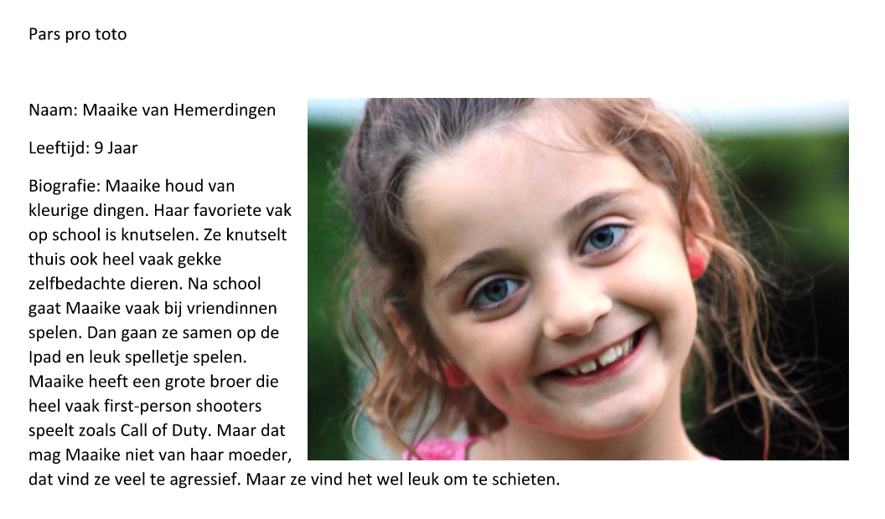

# Art and Video

## Assets Pipeline

As a player I want to have a main menu so that I can play the game.

As a Developer I want a level so that I can fill it with assets.

As a player I want different towers so that I can place them and shoot with it.

As a player I want a User Interface so that I can see additional information on my screen.

As a player I want controls so that I can control the game.

As a player I want points/coins so that I can spend them and upgrade/buy things.

As a Developer I want tower art so that I can update the towers with it.

As a player I want specials so that I can use them to win the game.

As a player I want lives so that I know when I lose.

As a Developer I want animations of towers/specials/enemies so that the game looks better.

As a player I want enemies so that I have something to fight against.

As a player I want an upgrade system so that my towers can get stronger.

As a player I want pickups so that the game gets more fun.

As a Developer I want User Interface art so that the UI looks better.

As a Developer I want cut scene so that I can apply them in the game.

As a player I want high scores so I have competition.

As a player I want a mini or end boss so that there is a challenge.

As a player I want different sound effects to make the game more fun.

As a player I want background music to make the game more alive.

As a player I want a How to Play screen so that I know how to play the game or which controls to use.

As a player I want particle effects so that the game looks cool.

As a player I want different levels so that the game is not monotonous.

As a player I want enemy Artificial Intelligence so that there is a specific challenge.

As a player I want lightning so that it’s not dark.

As a player I want collision so that I know when I hit an object.

As a Developer I want main menu art so that our main menu looks good.

As a Developer I want button art so that our buttons look better.

As a Developer I want art of enemies/towers/specials so that they look better.

As a Developer I want background art so that our background doesn’t look boring.

As a player I want a story to make the game more interesting.

As a player I want to be able to sell my towers so I can get some money back.

See our Scrum board.

<https://trello.com/b/zLpT8DJw/aim-project>

# Production Schedule

## Planning

See our Trello: <https://trello.com/b/zLpT8DJw/aim-project>

# Technical Specs

## Code Versioning

See our GitHub: <https://github.com/FadedSoul/Nature-s-Call/tree/master/Aim/Assets/Scripts>

## Code Objects

Timer/Delay  
------------------   
Time: Int  
Delay: Int

Menu’s  
------------------  
HighScore()  
Name:Var  
Menu Art

v

v

Bullets  
------------  
FlyOverScreen()  
DestroyOver Time()

v

Score  
-------------Score: Int  
  
Tower Art

Buttons  
------------------  
Button UI  
Button Art

Specials  
------------  
FlyOverScreen()

Towers  
------------------   
Shoot()  
  
Tower Art

Do Damage   
------------------   
Damage: Int

Enemies   
------------------ Move()  
Damage()  
Spawn over time()  
Enemy Art

Animations   
------------------

Base/Tree   
------------------

Destroy items   
------------------ Lives: Int health()